

NOVAC TECHNOLOGY SOLUTIONS

User Manual

Document Version No.: 1.00

Revision History
Version No | Reason For Changes | Author | Approver
0.01 | Draft | RAVI
1.00 | Reviewed & Approved the User Manual | RAVI | NIJANTHAN PL

Table of Contents
1. Introduction 4
2. Commission Payment screen changes 4

Introduction

As per the requirement, new changes are need to be restrict the commission payment for the motor fleet child policies and the details are given below.

Restrict the Commission For Motor Fleet policies

System should restrict the commission payment for the motor fleet child policies if premium is not fully collected for the corresponding child policies.

Path: Proposal Entry -> Commission Payment Screen002E
Screen Code: S0514

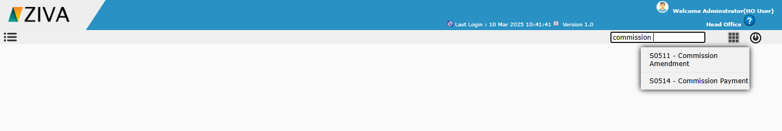

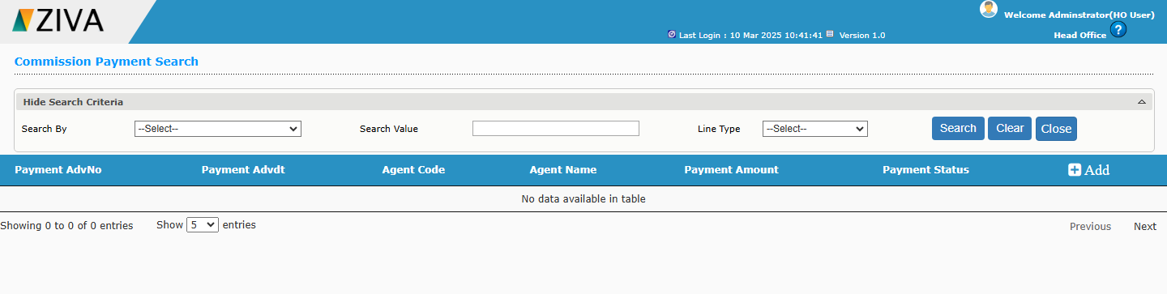
Click add button to add Commission Payment.

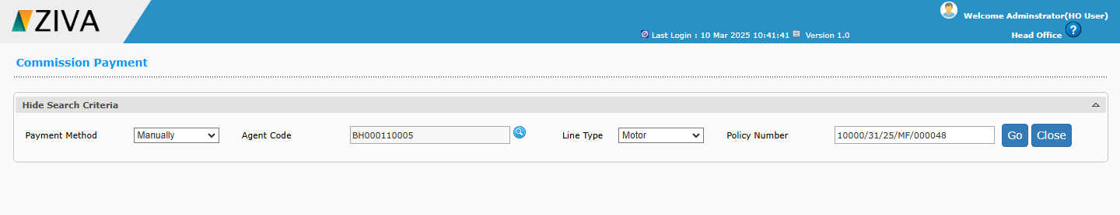

After enter all details and click the Go button, System should throws an error message “Premium not fully collected so commission payment not available” if the Motor Fleet policy if premium is not fully collected for the corresponding child policies.

